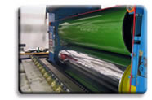
  Thermoforming
  Processing Guides

It is not difficult to extrude sheets of thermoplastic polyolefin (TPO) materials, or to fabricate parts from using conventional thermoforming equipment. Certain details of both processes, however, may differ from parameters used with other plastic materials. These guides will help you achieve the results you demand in your operations. Click on an image below to view the appropriate processing guide.
Our technical publications are available in the Adobe Acrobat® Reader® format. If your computer does not have the Reader installed, you can download it for free. Click here.
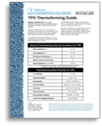  Thermoforming Guide | 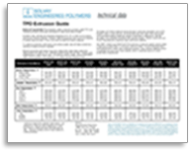  Extrusion Guide | 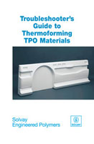  Troubleshooting guide
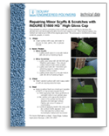  INDURE® E1500HG  Repair Guide | 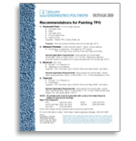  Painting Guide | 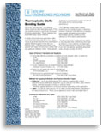  Bonding Guide

